TAOD Helper

--help submit request in TAOD

**Summary of Idea:**Auto tick test case and input some default fields in TAOD request submit form.

**Area of Improvement:**User experience

**Scenario:**

When QA need submit a TAOD request, he/she needs select the test case in a window and select some fields by different project and team.

**Current solution:** User has to go through a long way in a very deep tree step by step to find the test case, and input several fields by different project and team.

**Proposed solution:** User can copy the P4 path and system auto tick the test case and input the default fields.

How to start:

1. Get the rar file and unzip it;
2. Open **Chrome**, type “chrome://extensions:” in a tab to bring up the extensions page. Once on this page, check “Developer mode” to enable loading unpacked extensions.
3. Click “Load unpacked extension” or simply drag the “TAOD Chrome Extension” folder onto the page to load up the extension.

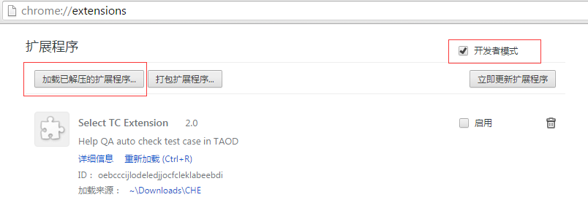

1. Once that done, you should immediately see the extension show up as a Browser Action with your icon in the toolbar window of the current tab



How to Use:

1. Open TAOD in Chrome explore, select a project

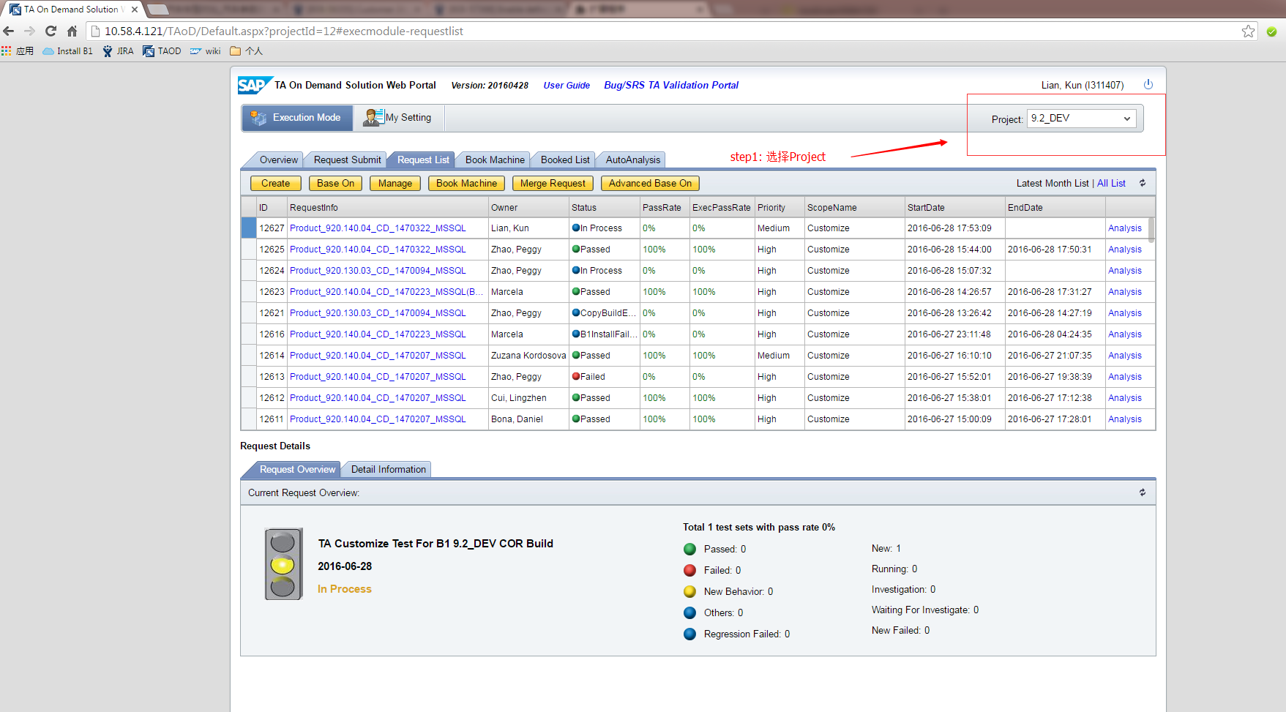

1. Click the green icon, it will input some fields and pop up for you to input the test case P4 path

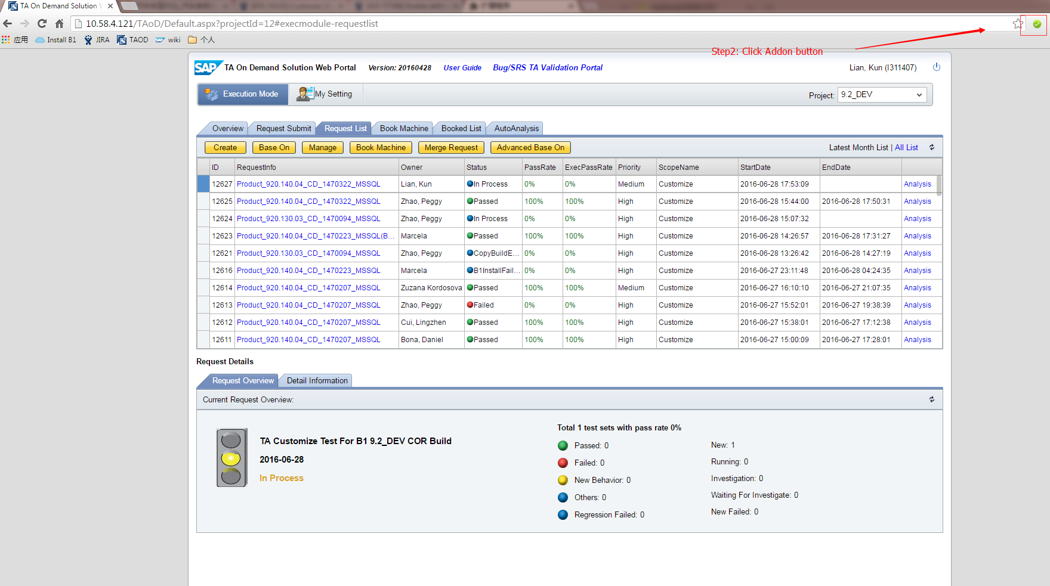

1. Input test case path

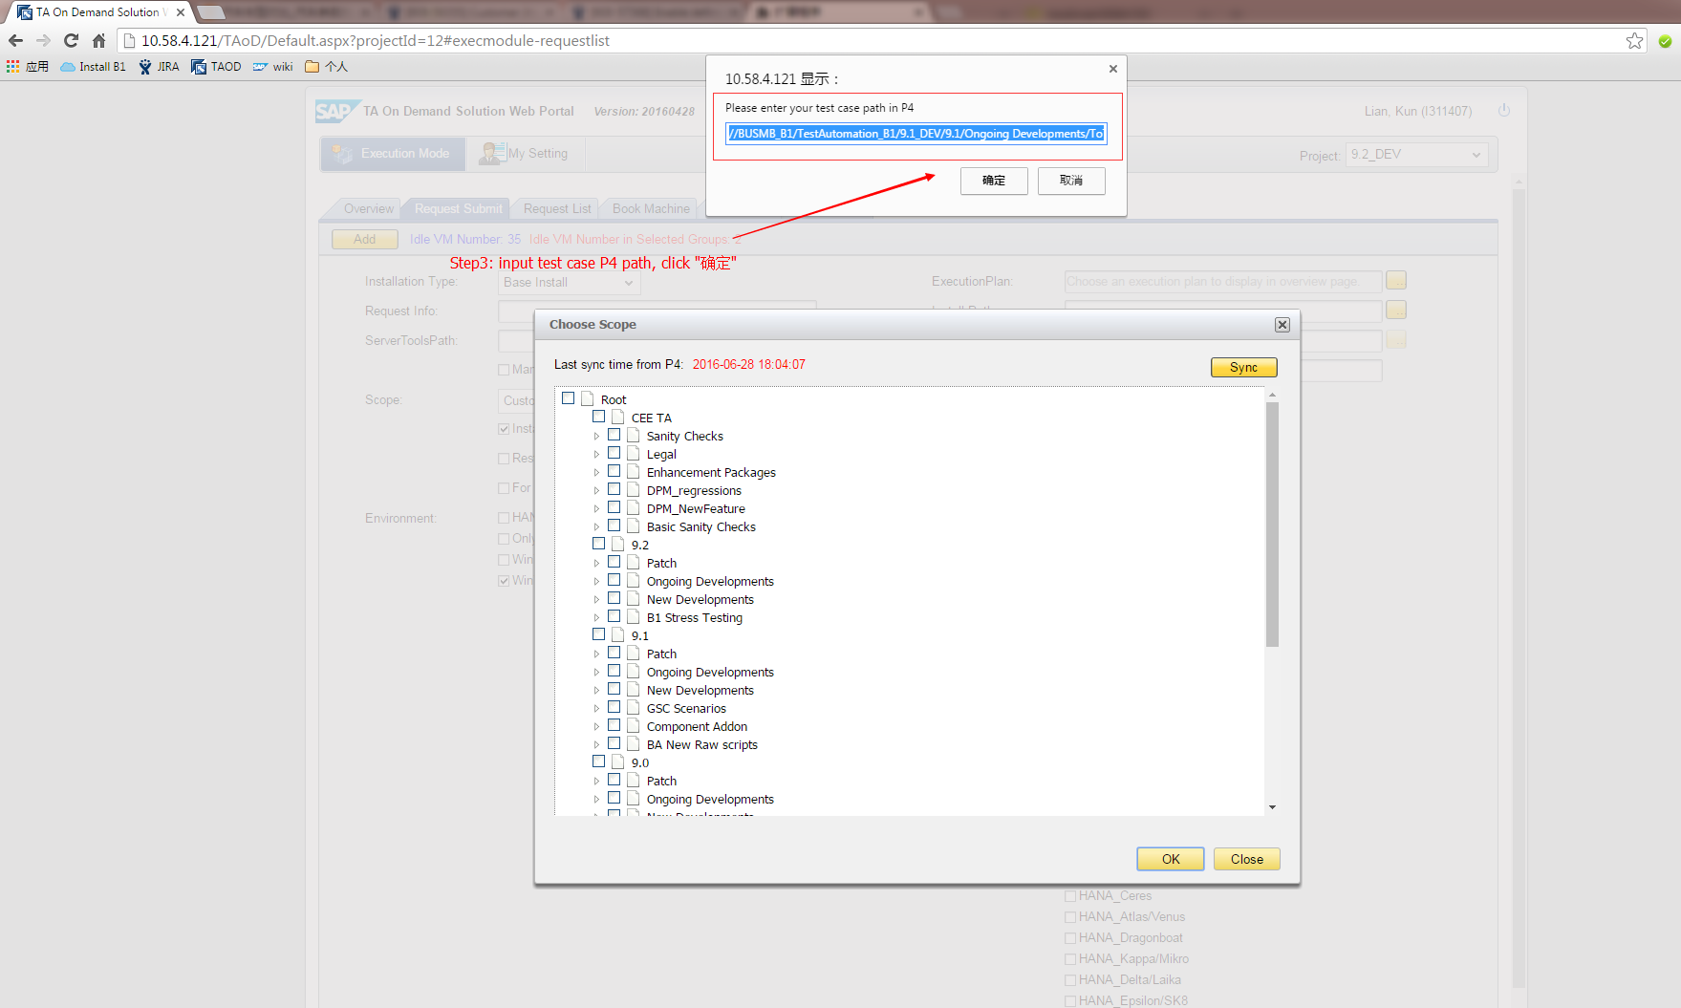

1. Close test case form

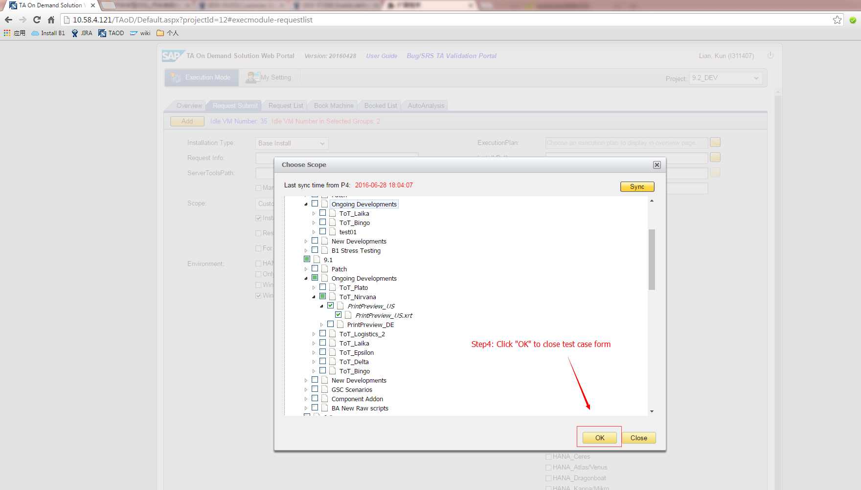

1. Choose a build

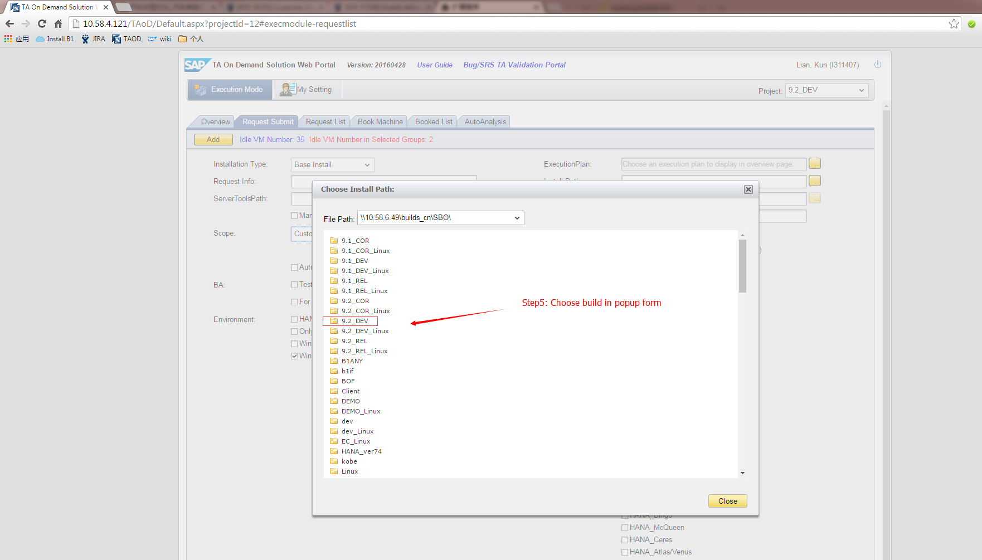

1. At last, check and submit

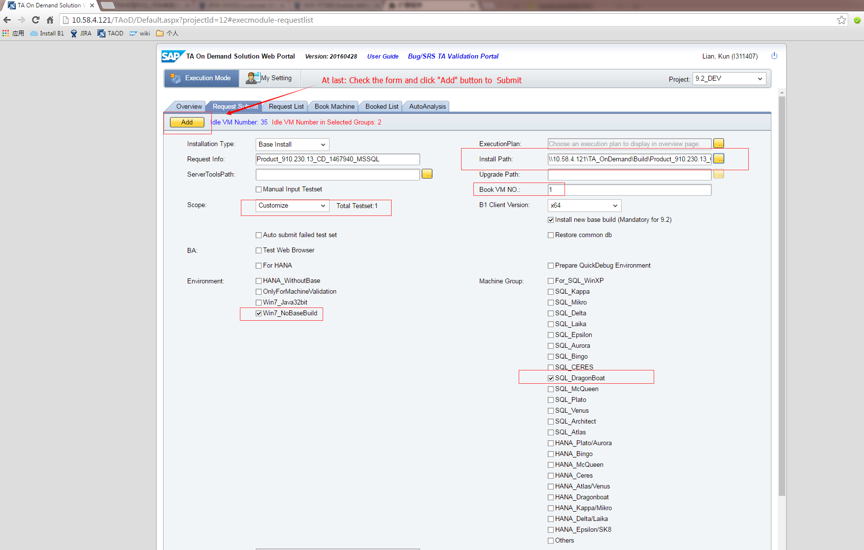

Notice:

1. now we support two kinds of P4 path:

One is full path which can directly copy from P4, for example: “//BUSMB_B1/TestAutomation_B1/9.1_DEV/9.1/New Developments/ToT_Apollo/DRQs/Qty Check/Qty Check.xrt”

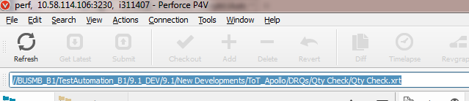

The other is a simple one from TAOD result form: “9.1/New Developments/ToT_Apollo/DRQs/Qty Check/Qty Check.xrt”

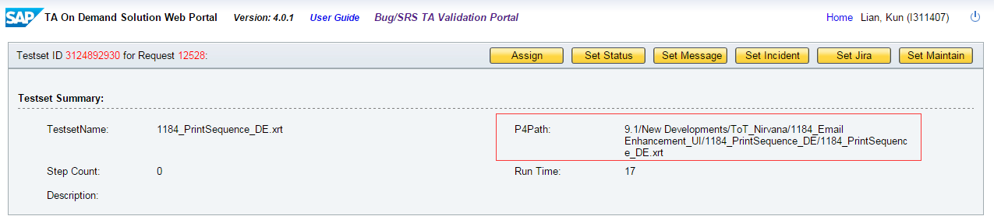

1. Only Chrome is supported now;
2. User can manually set his/her default test case and machine group, and remember to update book number to 1 if need auto book machine.